Object Oriented Programming (C&D) – Spring 2020
Quiz-03

Implement following ComplexNumber class:
class ComplexNumber
{
private:
int real;
int imaginary;
public:
ComplexNumber();
ComplexNumber(int , int ) ;
ComplexNumber(const ComplexNumber );
~ComplexNumber(); //Does Nothing.

void Input();
void Output();

bool IsEqual(ComplexNumber);
ComplexNumber Conjugate();
ComplexNumber Mult(ComplexNumber);
float Magnitude();
};
Sample Run: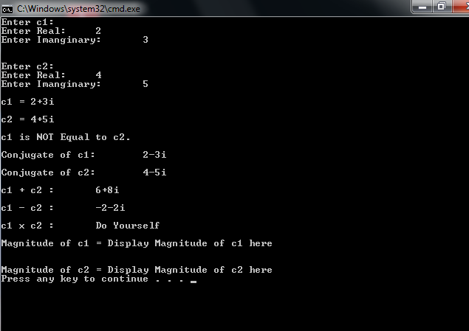

Important:
- Do not change class definition
- Submit only one RUNNING file YourRollNumber.cpp that contains class, its implementation and the driver Program. Do not submit .rar or .zip files.

